

Changes in automatic communication - CIM

1 Change in services 3
1.1 ETSO ScheduleService -> CIM ScheduleMarketService 3
1.2 ETSO ScheduleCallbackService -> CIM ScheduleMarketCallbackService (Server-Server) 4
1.3 ETSO StatusRequestService -> CIM StatusRequestMarketService 5
1.4 CIM StatusRequestMarketCallbackService (Server-Server) 6
1.5 CommonMarketService (Client-server) 7
2 Changes for Market Participant (Client-Server model) 7
3 Changes for Market Participant (Server-Server model) 7
4 Technical details 8
4.1 WSDL 8

Change in services
The following changes are implemented due to the transition from ETSO to CIM standard:

- Service ETSO ScheduleService is replaced by service CIM ScheduleMarketService. This service is returning only technical response RETURN_CODE
- Service ETSO StatusRequestService is replaced by service StatusRequestMarketService. This service is returning only technical response RETURN_CODE
- Service ETSO ScheduleCallbackService is replaced by service CIM ScheduleMarketCallbackService (it is a service on a Market Participants´ side for Server-Server communication)
- New service StatusRequestMarketCallbackService to get an answer to StatusRequest. (it is a service on a Market Participants´ side for Server-Server communication))
- Existing Service CommonMarketService to retrieve messages in Client-Server communication is now returning CIM messages

ETSO ScheduleService -> CIM ScheduleMarketService
Current synchronous service call to send ScheduleMessage
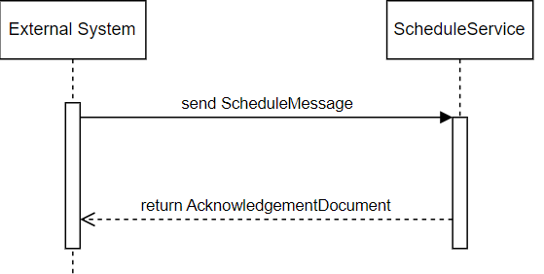
is replaced by an asynchronous service call ScheduleMarketService
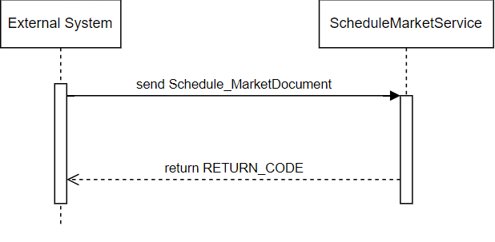
This service is fully asynchronous (response is only technical RETURN_CODE). Current synchronous AcknowledgementDocument (in CIM standard it is referred to as Acknowledgement_MarketDocument) is delivered to the new callback service ScheduleMarketCallbackService on Market Participants´ side (Server-Server model), or standard CommonMarketService (Client-Server model) can be collected.

ETSO ScheduleCallbackService -> CIM ScheduleMarketCallbackService (Server-Server)
Current callback service call ScheduleCallbackService
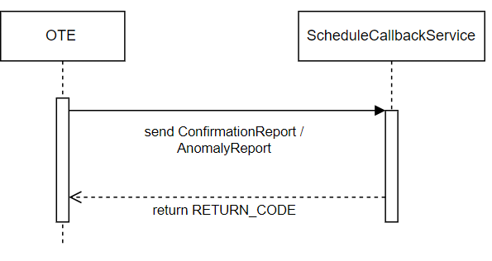
is replaced by a new service call ScheduleMarketCallbackService
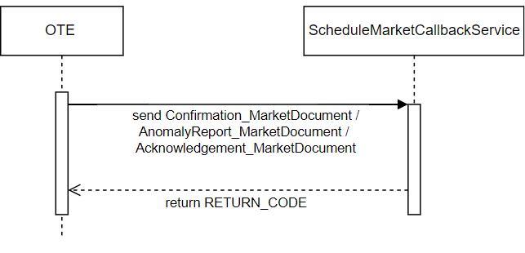
This service will be used to deliver Confirmation_MarketDocument and/or AnomalyReport_MarketDocument and/or Acknowledgement_MarketDocument, which are now provided in synchronous mode as answers to ScheduleService.

ETSO StatusRequestService -> CIM StatusRequestMarketService
Current synchronous service call StatusRequestService

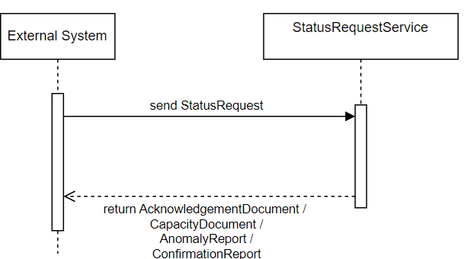

is replaced by an asynchronous service call StatusRequestMarketService
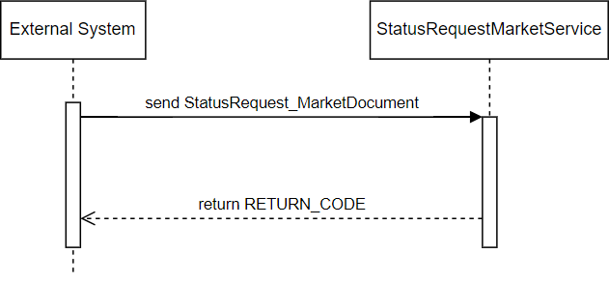
AcknowledgementDocument, CapacityDocument, AnomalyReport, and ConfirmationReport are in the ETSO service and returned synchronously as a response. In the CIM service, these documents will be delivered asynchronously based on the CIM StatusRequestMarketCallbackService (Server-Server model) or can be collected in the client-server model with the standard service MarketCallbackService.

CIM StatusRequestMarketCallbackService (Server-Server)
It is a new service to deliver response on StarusRequest in the Server-Server model.
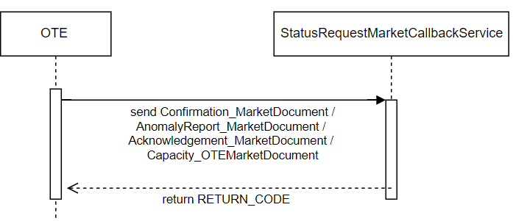

CommonMarketService (Client-server)
Standard CommonMarketService will be extended with CIM messages.
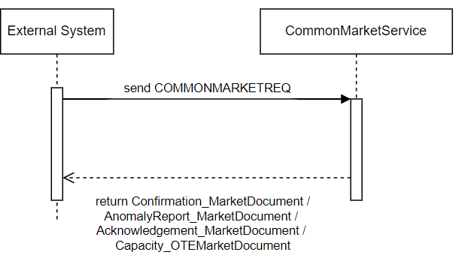

Changes for Market Participant (Client-Server model)
- ETSO services ScheduleService and StatusRequestService will be terminated
- Market Participant shall call new services ScheduleMarketService and StatusRequestMarketService. These services will now return only technical RETURN_CODE
- All documents (including Acknowledgement_MarketDocumentu) need to be collected by a standard service call CommonMarketService
- Service CommonMarketService on OTE side will be extended with new CIM structures struktury. ETSO structures won't be returned.
- A new form for automatic communication needs to be filled and submitted to OTE, where it shall be provided that CIM messages will be collected in the Client-Server model.

Changes for Market Participant (Server-Server model)
- ETSO services ScheduleService ScheduleCallbackService and StatusRequestService will be terminated
- Market Participant shall call new services ScheduleMarketService and StatusRequestMarketService. These services will now return only technical RETURN_CODE
- 2 new callback services - ScheduleMarketCallbackService and StatusRequestMarketCallbackService need to be implemented by a market participant. The CIM messages will be delivered to these services.
- A new form for automatic communication needs to be filled and submitted to OTE, where it shall be provided that Server-Server communication is requested and endpoints for new CIM callback services shall be provided. (It can be just one endpoint.)

Technical details

WSDL
WSDL for new CIM services (both standard and callback) is available at:
https://www.ote-cr.cz/en/documentation/electricity-documentation/documentation-for-sandbox-with-15-min-period?set_language=en
URL of CIM services for SANDBOX2 environment on OTE side
Service | URL
CIM ScheduleMarketService | https://csote.isotetest.ote-cr.cz:1443/KSX/cimScheduleMarketService
CIM StatusRequestMarketService | https://csote.isotetest.ote-cr.cz:1443/KSX/cimStatusRequestMarketService

URL of CIM services for PRODUCTION environment on OTE side
Service | URL
CIM ScheduleMarketService | https://market.ote-cr.cz/KSX/cimScheduleMarketService
CIM StatusRequestMarketService | https://market.ote-cr.cz/KSX/cimStatusRequestMarketService

